Autumn Walks 2021
1. 26th September 2021
Starting at 10.00 a.m.

"A Walk in the Woods "

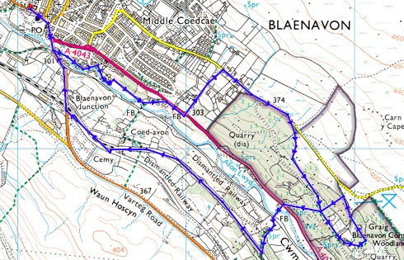

A short walk of about 6.5 km (4½ miles). It is suitable for families, but there's one steep ascent! We'll walk up to the Blaenafon Community Woodlands to look for signs of autumn, including mushrooms, toadstools and other fungi (and even blackberries). Then we'll walk down to join the old railway track (now SUSTRANS) and then back to the World Heritage Centre.

Some parts can be very muddy in wet weather, so appropriate footwear is needed.

Autumn Walks 2021
2. 31st October 2021
Starting at 10.00 a.m.

"Waun Afon and Milfraen Pit"

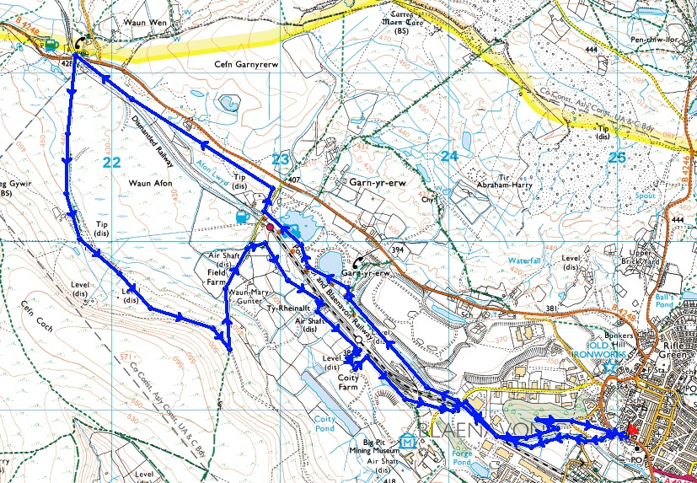

A walk of about 10 km (6 miles). It is suitable for older children, but isn't recommended for people with limited mobility. We leave the Heritage Centre to join and follow the SUSTRANS cycle path past Garn Lakes and then towards the Racehorse Inn. Near this point, we double back, visiting the Waun Afon marshes and passing the site of the former Milfraen Colliery (scene of a disastrous explosion in 1929) and then following the path past the Red Ash levels and the Coity Tips to return to base.

Some parts can be very muddy in wet weather, so appropriate footwear is needed.
Autumn Walks 2021
3. 28th November 2021
Starting at 10.00 a.m.

"On the Level(s)"

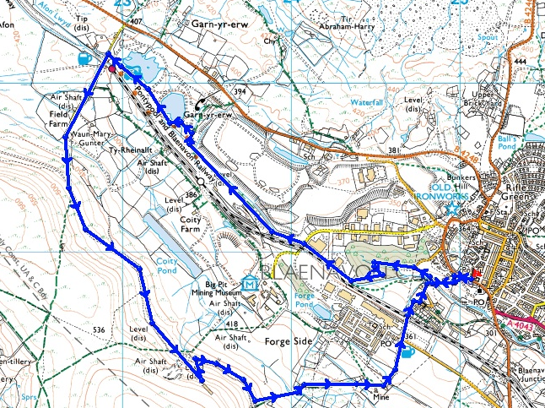

A fairly strenuous walk of about 8 km (5 miles), suitable for older children, but not recommended for young children or people with limited mobility. This walk climbs past old coal and iron workings to The Whistle Inn and then follows a hillside track. We visit the sites of a number of small drift mines, the last of which only closed in 2009. We then descend the path to Forgeside and back to the World Heritage Centre.

Steep in places and some parts can be very muddy in wet weather, so appropriate footwear is needed.

BWHEG Guided Walks 2021
Note: There won't be any walks in the coming December or January.

A new programme of Guided Walks will start on Saturday 27th February 2022, so watch this space!!!

