BWHEG Guided Walks Programme
Spring 2022

Good News! We're re-starting our regular programme of FREE guided walks exploring and enjoying the Blaenavon Heritage Landscape and its neighbouring post-industrial sites.

Some walks will be best for reasonably fit adults, but others will be suitable for older children or people with limited mobility. They will range in distance from around 5 to 12 km
(3 - 7 miles).

Most of the walks will start from outside the Blaenavon World Heritage Centre, at 10.00 a.m. on the last Sunday of each month, but others will be based in neighbouring areas – so keep your eyes open!

Please wear appropriate footwear and be prepared in case of wet weather (not unknown hereabouts!).

***If you'd like to be involved in leading or helping with our guided walks programme, why not join BWHEG and become part of the team?***
Spring Walks 2022

1. 27th March 2022
Starting at 10.00 a.m. starting from the Sports Centre car park in Pontypool (SO285006).

"The Height of Folly"

A walk of about 7 km (4 miles), suitable for families (fit ones, anyway!). We’ll visit the famous shell grotto and The Folly (superb views of the Usk valley), and then return via Trevethin and St Cadoc’s church, with its memorials to victims of the 1890 Llanerch Colliery Disaster.

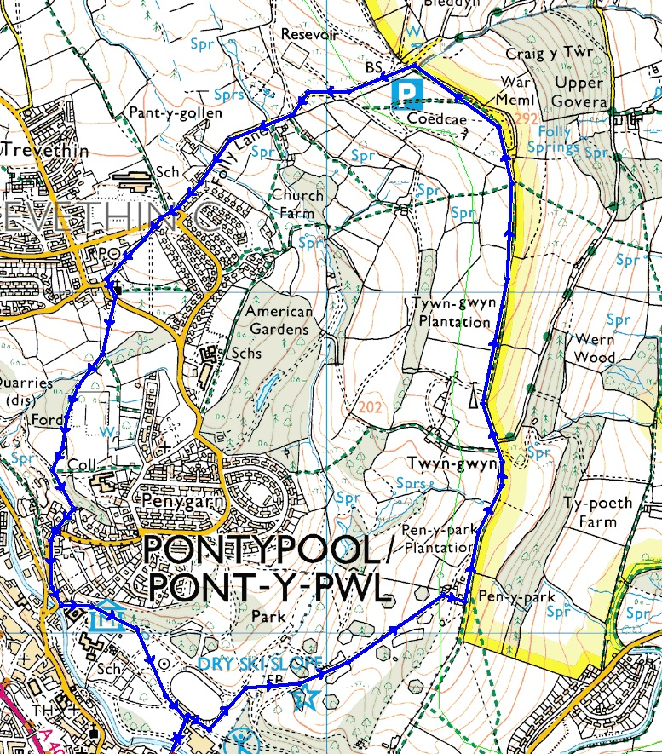

Some parts can be muddy in wet weather, so appropriate footwear is needed.
Spring Walks 2022
2. 24th April 2022
Starting at 10.00 a.m. at WHC.

"Back to The Dog Stone "

An old favourite, the Dog Stone on Varteg Hill is a monument to the memory of Carlo, a red setter accidentally shot during a grouse shoot in 1864. The "stone" is an iron monument, cast in Blaenafon.

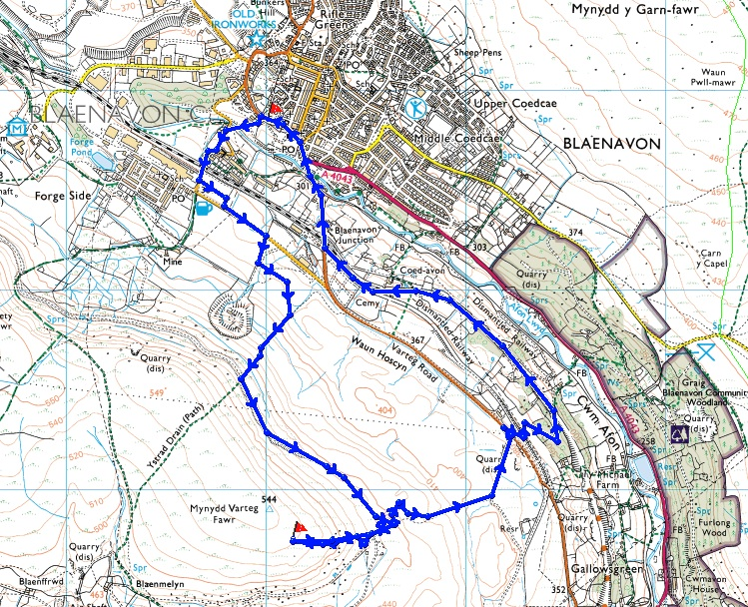

This is a walk of about 8 km (5 miles), with a couple of steep ascents (and, of course, descents!) It is suitable for older children, but could be difficult for people with limited mobility. We'll walk up to Forgeside, then to Varteg Hill and the Dog Stone. Then we'll walk down to join the old railway track (now the SUSTRANS cycle way) back to base.

Some parts can be very muddy in wet weather, so appropriate footwear is needed.
Spring Walks 2022
3. 29th May 2022
Starting at 10.00 a.m. at WHC.

"Both Ends of the Tunnel"

The Pwll Du tramway tunnel was once the longest of its kind in the world, bringing limestone from quarries in Tyla and Pwll Du to the Blaenafon Iron Works. This walk of about 9 km (6 miles) takes us to both ends of the tunnel.

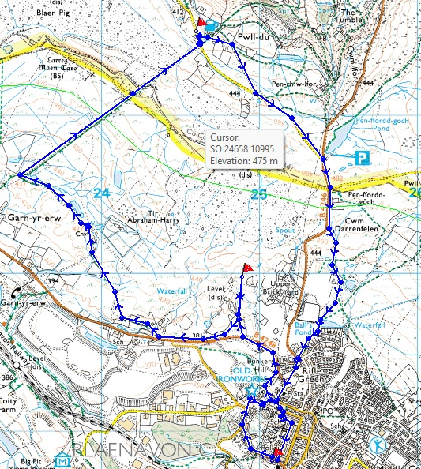

It’s hard going in places, and so unfortunately isn’t suitable for those with limited mobility, but it’s well worth the effort.

Some parts can be very muddy (and not just in wet weather!), so appropriate footwear is essential.

