BWHEG Guided Walks Programme
Summer 2022

More from our regular programme of FREE guided walks exploring and enjoying the Blaenavon Heritage Landscape and its neighbouring post-industrial sites.

Some walks will be best for reasonably fit adults, but others will be suitable for older children or people with limited mobility. They will range in distance from around 5 to 12 km
(3 - 7 miles).

Most of the walks will start from outside the Blaenavon World Heritage Centre, at 10.00 a.m. on the last Sunday of each month, but others will be based in neighbouring areas – so keep your eyes open!

Please wear appropriate footwear and be prepared in case of wet weather (not unknown hereabouts!).

***If you'd like to be involved in leading or helping with our guided walks programme, why not join BWHEG and become part of the team?***
Summer Walks 2022

1. 26th June 2022
Starting at 10.00 a.m. at WHC.

"Coety Mountain"

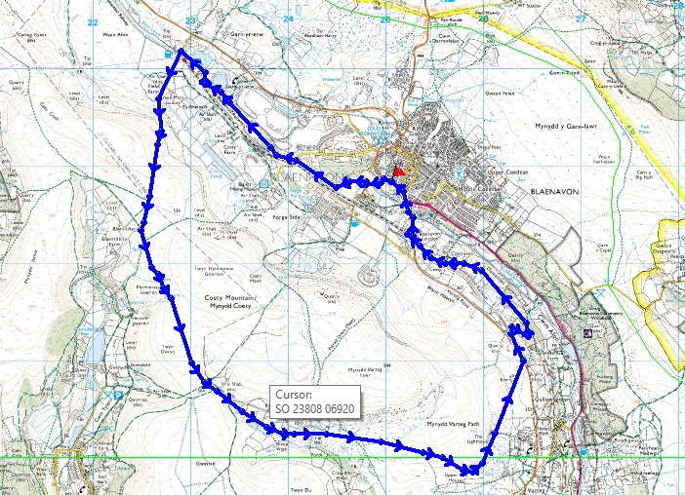

A strenuous walk of about 10 km (6 miles), following old mine roads, hill tracks and former railways.

After following the line of the restored Blaenavon Railway to the Whistle pub, we climb Coety Mountain, eventually descending via an old mine railway track skirting Mynydd Farteg Fach, and return to the World Heritage Centre once more via the Sustrans cycle track.

Some parts can be muddy in wet weather, and the walk can be exposed, so appropriate footwear and clothing are needed.
2. 31st July 2022
Starting at 10.00 a.m. at WHC.

"Milfraen Pits"

In memory of a disaster in July 1929 (www.nmrs.org.uk/minesmap/accidentsdisasters/monmouthshire/milfraen-colliery-explosion-blaenavon-1929/)

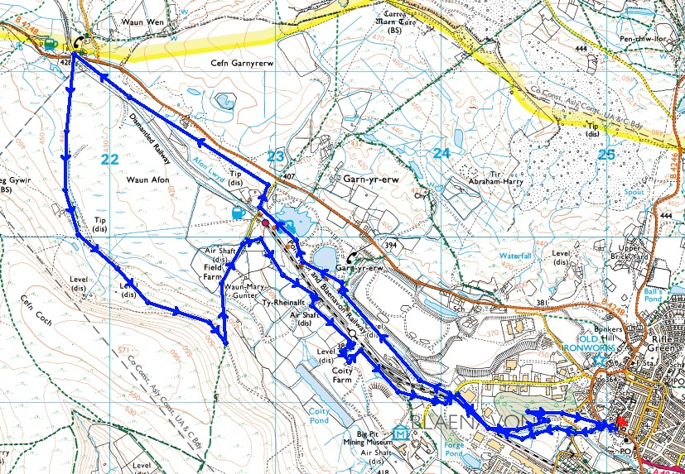

A walk of about 10 km (6 miles) over paths which may be muddy. Suitable for older children, but not recommended for people with limited mobility. We leave the Heritage Centre to join and follow the SUSTRANS cycle path through Garn Lakes and then towards the Racehorse Inn. Near this point, we double back, passing the sites of the former Milfraen and Red Ash collieries and then follow the path past the Coity Tips to return to base.

Some parts can be quite muddy in wet weather, but on the whole it’s walkable with appropriate footwear etc.

3. 28th August 2022

We’re going “foreign” for this walk - starting at 10.00 a.m. at the quarry car park (SO221125) between Clydach Village and Darenfelen.

"Cwm Pwcca"

This walk of about 7 km (6 miles) takes us to the Clydach Gorge, supposedly the haunt of fairies and reputedly (but no proof) once visited by Shakespeare.

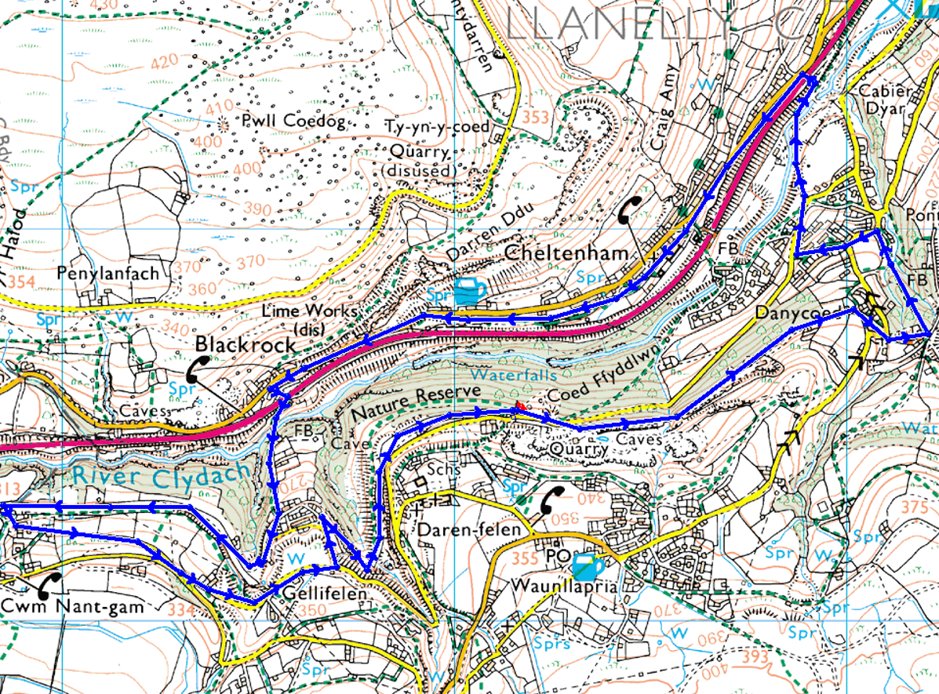

We’ll follow the old railway line (now SUSTRANS) and drop down through the woods to Clydach Village. We’ll then visit the old Clydach Ironworks before following the new Heads of the Valleys Road towards Cheltenham Village. Mourning en route the loss of the Drum and Monkey pub (if only for its name!), we’ll recross the road to the ancient Devil’s Bridge, before ascending to rejoin the railway line to Cwm Nant Gam, before returning to our stating point.

There are a couple of steep ascents (and descents), and some parts can be quite muddy in wet weather, but on the whole it’s walkable with appropriate footwear etc.

